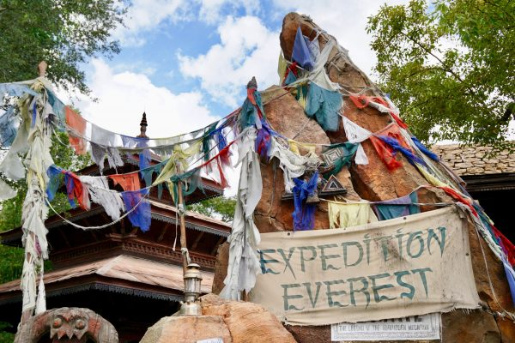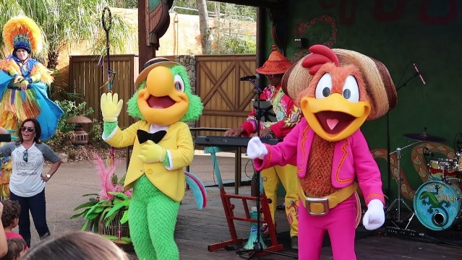

**Class of 2022 Sophomore Trip**

**To Disney’s Animal Kingdom**



**2022**

0

**ALLOWED:**

* Approved Group Shirt OR School Spirit Shirt OR School Uniform Shirt
* Jeans / Capris
* Bermuda / Cargo Shorts
* Sweaters / Jackets

Items That Have Stay On Bus:

* Pillows & Blankets
* Backpacks

**NOT ALLOWED:**

* NO Leggings
* NO Work Out Pants
* NO Athletic Shorts
* NO Sandals
* NO Food or Water
* NO Group Shirts that weren’t approved by Activities Office

MUST be at Ferguson at **4:45 AM**

Bus will be leaving at **5:15 AM** SHARP

We will be leaving the park at **6:30 PM** SHARP